System Decomposition

1. Subsystem diagram

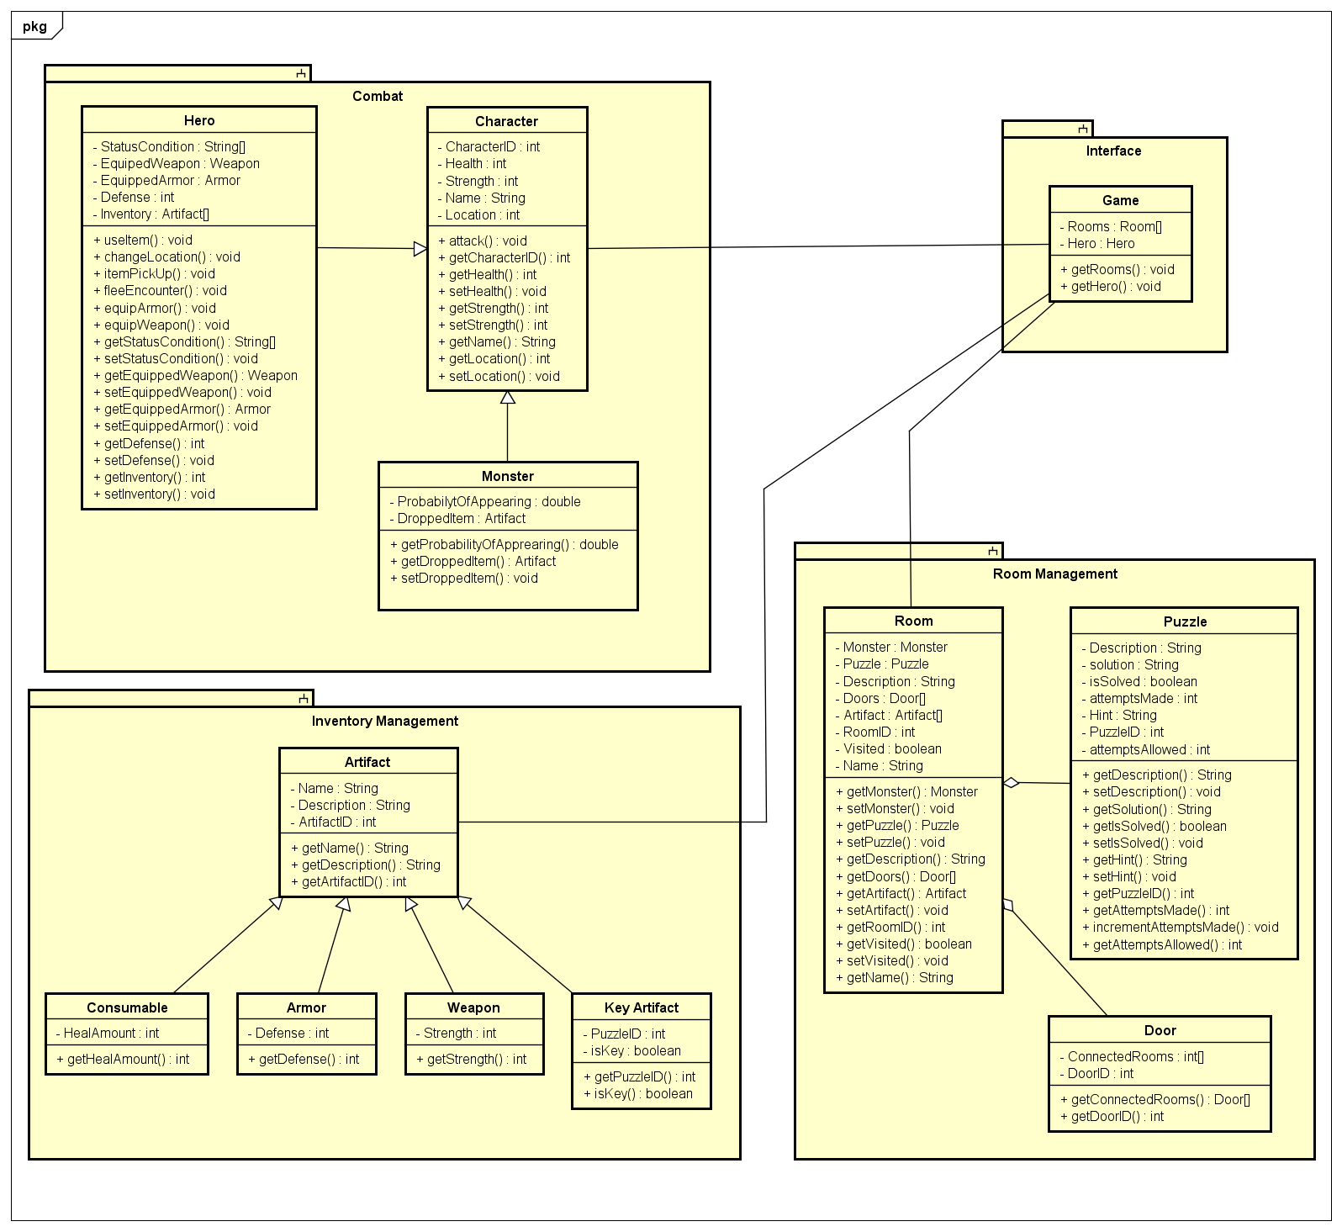

1. Subsystem Descriptions
   * ***Combat Subsystem***: The combat System is responsible for handling the interaction between hero and monster in which both character types will be able to attack one another. Users will be able to enter commands for the combat system through the interface subsystem.
   * ***Room Management Subsystem***: The room management subsystem will be responsible for the generation of rooms.
   * ***Interface Subsystem***: The Interface subsystem will be responsible for the interpretation of user input and the interaction between subsystems. Beginning tasks including but not limited to combat, artifact manipulation, and room interaction.
   * ***Inventory Subsystem***: The inventory subsystem will be responsible for keeping track of all artifacts available within the game system.